.NET COURSERA COURSE

2100090166  
 J.KASAIAH

CS&IT

1. ASP.NET for Experienced Developers FINAL CERTIFICATE

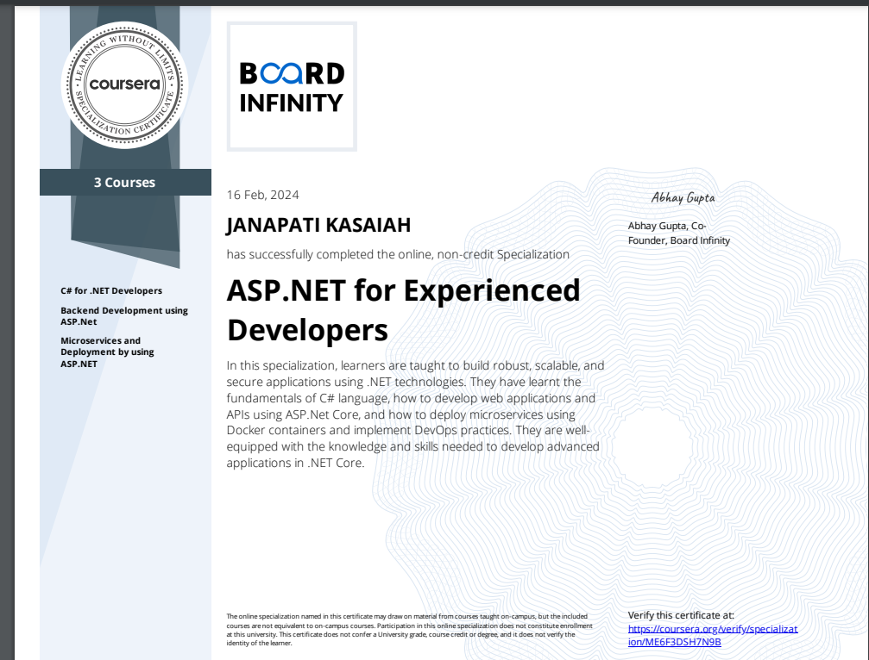

2.C# for .NET Developers certificate

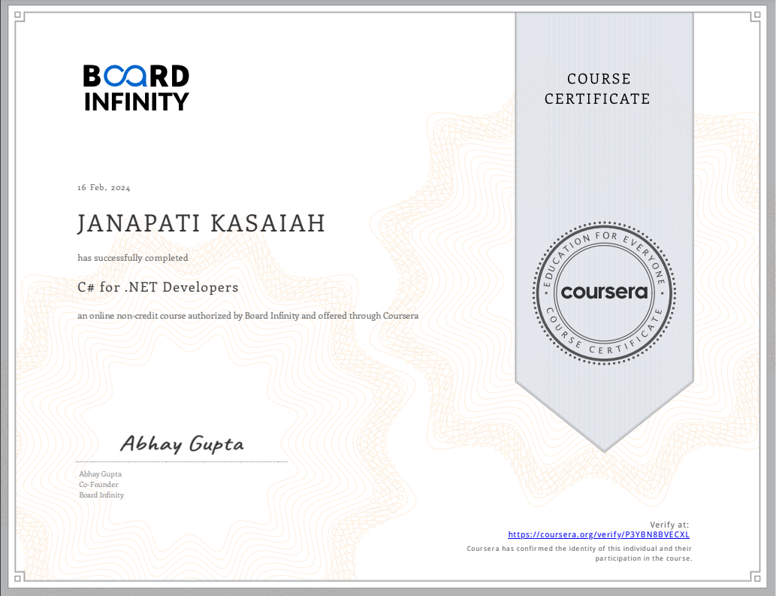

1. Microservices and Deployment by using ASP.NET

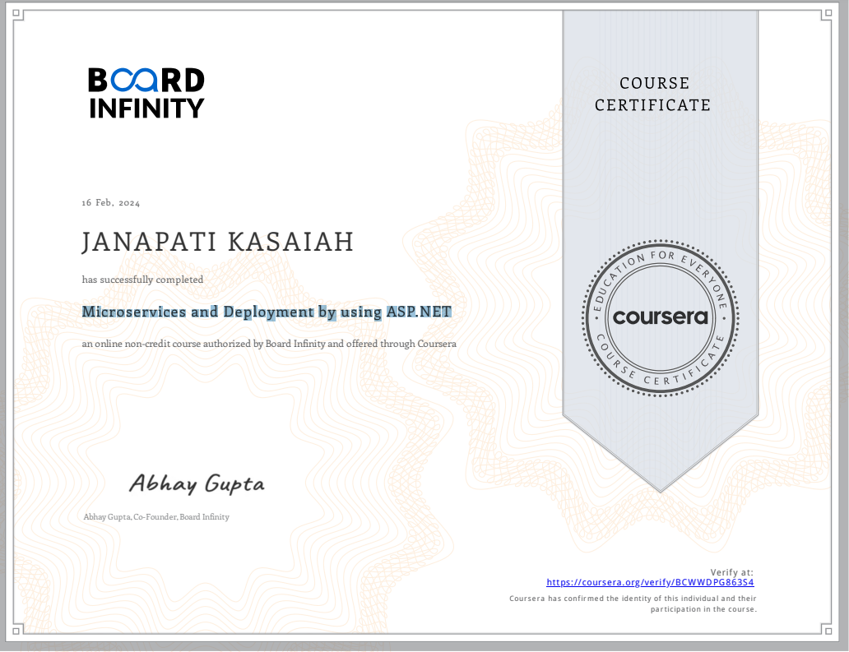

1. Backend Development using ASP.Net

